Brian Hunt August 11, 2024
www.forgottenpatriots.org.

Moses Stiles, Patriot of Florida and Duanesburg New York

Moses Stiles served in the 1st New York Continental Regiment from 1776 – 1783, virtually the entire length of the Revolutionary War. The service record of Moses Stiles in the 1st New York Continental Regiment is summarized in the table below:
Service of Moses Stiles in the 1st New York Regiment during the Revolutionary War
Date | Roll | Rank | Company Commander | Place
Feb 12, 1776 | Enlistment | Private | Captain David Lyon
Feb – Mar 1776 | Pay | Private | Captain David Lyon
Jun 5, 1777 | Muster | Private | Captain Robert McKeen
Jun 29, 1777 | Muster | Private | Captain Robert McKeen
Nov 14, 1777 | Muster | Private | Captain Robert McKeen
Feb 9, 1778 | Muster | Private | Captain Robert McKeen
Mar 17, 1778 | Muster | Private | Captain Robert McKeen
Mar & Apr 1778 | Pay | Private | Late Captain  Robert McKeen
May 5, 1778 | Muster | Private | Lt. Ten Broek | Chester County
Jun 9, 1778 | Muster | Private | 7th Company
Jul 6, 1778 | Muster | Private | 7th Company
Jun 1778 | Pay | Private | Lt. Sherwood
Aug 6, 1778 | Muster | Private | 7th Company
Sept 4, 1778 | Muster | Private
Oct 7, 1778 | Muster | Private | 7th Company | Peekskill
Nov 1, 1778 | Muster | Private | Late Captain  Robert McKeen
Jan 11, 1779 | Muster | Private | Late Captain  Robert McKeen
Mar 31, 1779 | Muster | Corporal | Captain Nicholas Van Rensselaer
Jun 1, 1779 | Muster | Corporal | Captain Nicholas Van Rensselaer | Fort Schuyler
Dec 1, 1779 | Muster | Corporal | Captain Nicholas Van Rensselaer | Fort Schuyler
Jan 3, 1780 | Muster | Corporal | Captain Nicholas Van Rensselaer | Fort Schuyler
Jan & Feb 1780 | Pay | Corporal | Captain Nicholas Van Rensselaer | Fort Schuyler
Mar 1, 1780 | Muster | Corporal | Captain Nicholas Van Rensselaer | Fort Schuyler
May & Jun 1780 | Pay | Corporal | Captain Nicholas Van Rensselaer | Fort Schuyler
Jul 10, 1780 | Muster | Corporal | Captain Nicholas Van Rensselaer | Fort Schuyler
Sep 1, 1780 | Muster | Corporal | Captain Nicholas Van Rensselaer | Fort Schuyler
Dec 30, 1780 | Muster | Corporal | Captain Nicholas Van Rensselaer | Fort Schuyler
May 1, 1781 | Muster | Corporal | Captain Benjamin Hicks | West Point
May 12, 1782 | Muster | Corporal | Captain Benjamin Hicks
Jun 4, 1782 | Muster | Corporal | Captain Benjamin Hicks
Jul 9, 1782 | Muster | Corporal | Captain Benjamin Hicks
Sept 7, 1782 | Muster | Corporal | Captain Benjamin Hicks
Nov 6, 1782 | Muster | Corporal | Captain Benjamin Hicks
Dec 1, 1782 | Muster | Corporal | Captain Benjamin Hicks
Jan 17, 1783 | Muster | Corporal | Captain Benjamin Hicks
Jan 1783 | Pay | Corporal | Captain Benjamin Hicks
Feb 20, 1783 | Muster | Corporal | Captain Benjamin Hicks
Apr 22, 1783 | Muster | Corporal | Captain Benjamin Hicks
May 21, 1783 | Muster | Corporal | Captain Benjamin Hicks
Aug & Sept 1783 | Pay | Corporal | Captain Benjamin Hicks
Oct – Dec 1783 | Pay | Corporal | Captain Benjamin Hicks
Sources:
U.S., Revolutionary War Service Records, New York, 1st Regiment, Moses Stiles, NARA publication M881, NARA catalog ID 570910, roll 0665, 61 digital images, Fold3.com. U.S., Revolutionary War Rolls, New York, 1st Regiment, 1777 – 1783, (Folders 10-18), 781 digital images, Ancestry.com.

The First New York Regiment was active from 1776 – 1783. In 1776, its commander was Colonel Alexander McDougall. From 1777 – 1783 the regiment wa under the command of Colonel Goose Van Schaick. The 1st NY was assigned to the Northern Department of the Continental Army under the command of General Phillip Schuyler. The 1st NY was sent to Fort Schuyler (later Fort Stanwix) in what is now Rome NY on August 23, 1777. The 1st NY remained at Fort Schuyler through the spring of 1778. By 1781, the decision was made to abandon Fort Schulyer, and the 1st New York was dispatched to the fort at West Point NY. The regiment took part in the siege of Yorktonw in October 1781. The 1st New York found its final quarters in New Windsor NY in the spring of1783 and was disbanded at the end of that year.
After the war Moses Stiles lived in the Town of Florida New York where he married Catherina Straile on January 12, 1785. The children of Moses and Catharina Strail Stiles children listed below:
Children of Moses and Catharina Straile Stiles
Name | Birth | Marriage | Death
Margaret Stiles | Mar 13, 1785 Remsens Bos NY | _______ Mitchell  unknown | Nov 6, 1873, burial Menands NY
Eve Stiles | unknown | ______ Holden | unknown
Elizabeth Stiles | 1789 | Peter Boice | Jan 15, 1870 Cooperstown NY
Sources:
U.S., Revolutionary War Pensions, Pension W.24373, veteran Moses Stiles, pensioner Catrina Orchard, Declaration of Peter Bice, May 18, 1832, NARA publication M804, NARA catalog ID 300022, Record Group 14, images 7-8 of 61, Fold3.com.
U.S., Dutch Reformed Church Records in Selected Places, 1639 – 1989, Schenectady Baptisms, volume 3, book 43, page 327, baptism of Margaret Styles, daughter of Moses Styles and Catharina Straile, Remsens Bos New York, birth March 13, baptized August 16, 1785 in Schenectady NY, page 38 of 113, digital image 76 of 120, Ancestry.com.
New York, Albany County, Menands, Albany Rural Cemetery Burial Cards, 1791 - 2011, burial record of Mrs. Margaret Mitchell, died Nov 6, 1873, age 88, death location Troy NY, digital image 1192 of 1376, Ancestry.com.
Barber, Gertrude, A., Deaths Taken from the Otsego [NY] Herald & Western Advertiser & Freeman’s Journal,1939, Volume 3, deaths 1862 – 1975, death of Mrs. Peter Bice, January 15, 1870, Cooperstown, digital image 263 of 315, Ancestry.com.

John Strail, Catharina’s father, owned a farm in Florida NY, a town bordering Duanesburg to the north. Catharina’s stated that she and Moses and their children lived in Florida after the war. Moses Stiles was enumerated in the 1790 Census of Duanesburg New York in household with this composition:
1790 Household of Moses Styles in Duanesburg New York
Males 16 and over | Females | Total Household Members
1 | 3 | 4
Source:
U.S. Census, 1790, New York, Albany, Duanesburg, household of Moses Styles, The National Archives in Washington, DC; Washington, DC; First Census of the United States, NARA Publication Series: M637; Roll: 6; Page: 215; Family History Library Film: 0568146.

John Strail’s family was enumerated in the 1790 census of Florida. The composition of the 1790 household of John Strail is shown in the table below:
1790 Household of John Strail in the Town of Mohawk, Montgomery County New York
Males under 16 | Males 16 and over | Females | Total Members
2 | 3 | 5 | 10
Source:
U.S. Census, 1790, New York, Montgomery, Mohawk, household of John Strail, The National Archives in Washington, DC; Washington, DC; First Census of the United States, NARA publication Series: M637; Roll: 6; Page: 46; Family History Library Film: 0568146.

The Town of Florida was created March 12, 1793 from a part of the Town of Mohawk. John and Margaret Strail had 2 sons born prior to 1774. It is likely that the 3 males 16 and over in this household were John Strail [Sr.], Henry Strail, and Matthias Strail. This evidence supports the conclusion that Moses and Catharina Stiles and two of their children lived in Duanesburg in 1790.
Moses Stiles was granted a lease on farm 159 in Duanesburg on August 24, 1787 by James Duane, the owner and landlord of most of the Town of Duanesburg. Land owned by Duane was leased to tenant farmers in return for annual rent payments. In a record of Duane family properties in Duanesburg, farm 159 is described as being 100 acres and as being of poor quality. In a 1798 accounting of rentals of James Duane’s land in Duanesburg, farm 159 is listed as having been leased by Moses Stiles; however, a note above his name states ‘Philip Spencer assign’. This record also shows no arrears for rent payments for the years 1795-1798. Philip Spencer is recorded in tax assessment records as owning a farm in Duanesburg for the years 1800 – 1802.
In 1800, John Strail was enumerated in the 1800 census of Duanesburg. His household is shown in the table below:
1800 Household of John Strail in Duanesburg New York
Males  under 10 | Males  16 - 25 | Males  26 - 44 | Females  under 10 | Females  26 - 44
1 | 1 | 1 | 2 | 1
Source:
U.S. Census, New York, Albany, Duanesburg, household of John Strail, NARA publication Series: M32; Roll: 22; Page: 29; Image: 34; Family History Library Film: 193710.

The 1800 household of John Strail very likely is John Strail Jr. the son of John Strail of the Town of Florida due to the age of the head of household. There is no record of John Strail leasing land in Duanesburg. Perhaps he was sub-leasing land, maybe even farm 159 from Philip Spencer, who owned land in Dutchess County as well as in Duanesburg and Princetown in Albany County in the period 1799 – 1804.
The location of farm 159 in Duanesburg is shown below on the excerpted image of an 1866 map of Duanesburg:
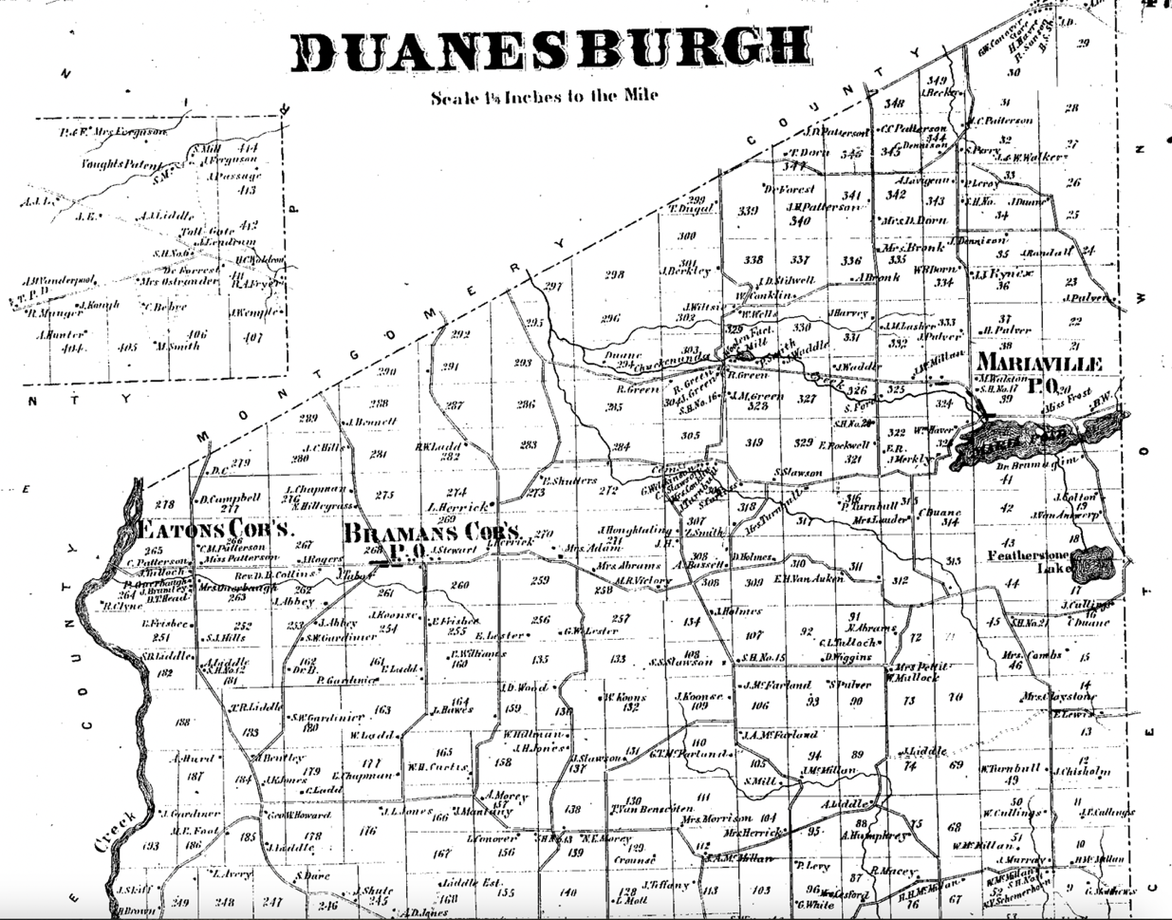
The author of this report purchased farm 159 in Duanesburg jointly with his brother in 1986. The land is on top of a hill near the highest elevation in the town. It had been used as a dairy farm by the previous owners. There was an old farmhouse on the property as well as two old barns. These building were of timber frame construction, a method of construction used mainly prior to the Civil War. The house had well-worn wide plank flooring in the second story. It is possible that part of the house could have been built prior to 1790, but that is unknown. Moses Stiles died in 1790. No record of his burial has been found. It is possible he was buried on his farm but no evidence has been found.
Who were the Parents of Moses Stiles?
The evidence for the parents of Moses Stiles is found in Revolutionary War military records, not from New York, but rather from Massachusetts. Moses Stiles is found in a list of men from Pittsfield MA who were sent to Cambridge MA on April 22, 1775, 3 days after the battles of Lexington and Concord which began the Revolutionary War. A second record from Pittsfield lists Moses Stiles as one of the men raised in Pittsfield MA for the company commanded by Captain McKain [McKeen] for the New York regiment commanded by Col. Van Shaick. This correlates with the evidence for Moses Stiles in the 1st New York Regiment. Catherina, widow of Moses Stiles applied for and was granted a widow’s pension based on his service in the New York Continental Regiment. This evidence supports the conclusion that Moses Stiles of Pittsfield MA was the Moses Stiles who married Catharina Strail in Florida NY. Moses Stiles was born March 12, 1743 in Westfield Massachusetts, to parents Ephraim and Jemima Meacham Stiles.
Moses Stiles exemplifies the forgotten patriot. His service in the Revolutionary War was extensive, encompassing virtually the entire time period of the war. He had a family and a farm in upstate New York after the war, but his life was cut short for unknown reasons, and he remains unrecognized and unacknowledged for his service in the founding of our country. Hopefully this report stands as such an acknowledgement, limited in public awareness though it may be.

U.S., National Park Service, The 1st Regiment of the Continental Line 1776 – 1783, accessed at https://www.nps.gov/articles/000/the-1st-new-york-regiment-of-the-continental-line-1776-1783.htm. U.S., Revolutionary War Service Records, New York, First Regiment, Alexander McDougall, Colonel, NARA publication M881, NARA catalog ID 570910, roll 0659, 35 digital images, Fold3.com.
U.S., Dutch Reformed Church Records, 1639 – 1989, Schenectady Marriages Volume 5, Book 45, page 38, marriage of Moses Styles and Catharina Straile from Remsens Bos, January 12, 1785, digital image 50 of 113, Ancestry.com. Remsens Bos aka Remsens Bush is an old settlement in the Town of Florida. FindaGrave, Remsen Bush Cemetery, Town of Florida New York, FindaGrave.com.
New York, Montgomery County Deeds, Deed Book 9, pages 60-62, June 1, 1802, consideration $2,400, deed of John Strail and Margaret his wife of the Town of Florida to John Merlmoyer of the Town of Princetown, Albany County, land in the town of Florida, lot 6 of the 1735 patent of Anne Wilmot, images 36-7 of 577, FamilySearch.org.
U.S., Revolutionary War Pensions, Pension W.24373, veteran Moses Stiles, pensioner Catrina Orchard, Declaration of Catrina Orchard, September 21, 1832, NARA publication M804, NARA catalog ID 300022, Record Group 14, images 4 - 6 of 61, Fold3.com.
Town of Florida, Comprehensive Plan, Montgomery County New York, February 1996, page 13. New York, Wills and Probate Records, Schoharie County Wills, Testaments, Volumes A-3, Will of John Strail of Sharon, will dated 7 May 1805, images 147-8, Ancestry.com. Note: John Strail sold his farm in the Town of Florida in 1802 as cited above. Henry Strail and Mathias Strail are listed as sons and heirs in the will of John Strail. U.S. Census, 1850, New York, Onondaga, Fabius, Household of Henry Strail, age 77, The National Archives in Washington, DC; Record Group: Records of the Bureau of the Census; Record Group Number: 29; Series Number: M432; Residence Date: 1850; Home in 1850: Fabius, Onondaga, New York; Roll: 567; Page: 126b. Jones, Henry Z. and Lewis B. Rohrbach, Even More Palatine Families, Rockport ME: Picton Press, no date, child of Johannes Streil, Mathias, born November 12, 1769, citing Albany Reformed Church Book, digital image 721 of 836, Ancestry.com.
Duane family papers, 1665-1916 (bulk 1756-1900). Series IV: Bound volumes, 1754-1843, General Account of Duane Property Holdings, 1765 – 1789, page 51, Farm 159, 100 acres, 2 perches, 27 roods, quality bad, Grantee Moses Stiles date 1787 August 24, consideration ‘in fee on perpetual rent charge’, New York Historical Society, bound volume of handwritten parchment documents, accessed at https://nyheritage.contentdm.oclc.org/digital/collection/p16124coll1/id/32932. New York, Schenectady County Land Records, 1888-9, February 7, 1888, consideration $819, Deed of John A. DeRemer, Exec of the Lat Will and Testament of Cornelius Duane et al to David Cady Smith, four certain deeds, first dated August 24, 1787 made between James Duane and Moses Stiles, farm known as number 159, 100 acres, digital image 174 of 619, FamilySearch.org.
Duane Family Papers, 1665 – 1916, Series IV, 1754 – 1843, Rentals in Duanesburg, 1795 – 1798, Spread 20: abstract of rentals in Duanesburgh for lots 154 – 161, New York Historical Society, accessed at https://nyheritage.contentdm.oclc.org/digital/collection/p16124coll1/id/33262. Moses Stiles is listed as the tenant of farm 159. Above the name of Moses Stiles is written “Philip Spencer assign”. Annual rent is listed as £6, 0s, 10p. No arrears are shown for the years 1795 – 1798.
New York, Tax Assessment Rolls of Real and Personal Estates, 1799 – 1804, New York (State), Comptroller's Office. Tax Assessment Rolls of Real and Personal Estates, 1799–1804. Series B0950 (26 reels). Microfilm. New York State Archives, Albany, New York.
New York, Tax Assessment Rolls of Real and Personal Estates, 1799 – 1804, New York (State), Comptroller's Office. Tax Assessment Rolls of Real and Personal Estates, 1799–1804. Series B0950 (26 reels). Microfilm. New York State Archives, Albany, New York.
1866 Map of Schenectady County New York, Whitlock’s, New Haven CT. Accessed at https://www.duanesburg.net/town-historian/pages/1866-schenectady-county-map.
New York, Schenectady County Land Records, Volume 1135, page 321, deed of Joseph Armand Hebert and Madeleine Hebert to Brian and Todd Hunt, 100 acres of land in Duanesburg, farm number 159.
Massachusetts, State Archives Collection, Colonial Period, 1622 – 1788, Volume 146, Page 497, List of Men Raised in the Town of Pittsfield By Captain David Noble, April 22, 1775, 51 men, 26 weeks, Boston, MA: Massachusetts State Archives, digital image 57 of 854, FamilySearch.org.
Massachusetts, State Archives Collection, Colonial Period, 1622 – 1788, Volume 146, page 65, List of Men raised by Captain John Strong in Pittsfield MA, no date, Moses Stiles, listed as in the company commanded by Capt. McKain in Col. Van Schaick’s Regiment, enlisted for the duration of the war, Boston, MA: Massachusetts State Archives digital image 65 of 854, FamilySearch.org.
U.S., Revolutionary War Pensions, Pension W.24373, veteran Moses Stiles, pensioner Catrina Orchard, NARA publication M804, NARA catalog ID 300022, Record Group 14, 61 images, Fold3.com.
Massachusetts, Town and Vital Records, Westfield Births, Marriages, and Deaths, Book A, page 168, birth of Moses Stiles, March 12, 1743, parents Ephraim and Jemima Stiles, digital image 1583 of 3118, Ancestry.com. Massachusetts, Town and Vital Records, Westfield Births, Marriages, and Deaths, marriage of Ephraim Stiles and Jemima Mecham, August 5, 1736, digital image 560 of 3118, Ancestry.com.

